A PERSONAL VOICE-ACTIVATED DESKTOP ASSISTANT

Karan Anand Jain Computer Science engineering AIML

*Chandigarh University* Chandigarh, INDIA [karanjainkkk765@gmail.com](mailto:karanjainkkk765@gmail.com)

Mitali Gupta

Computer Science engineering AIML

*Chandigarh University* Chandigarh, INDIA [mitaligupta615@gmail.com](mailto:mitaligupta615@gmail.com)

Aayush Adhikari Computer Science engineering AIML

*Chandigarh University* Chandigarh, INDIA [aayushadhikariash@gmail.com](mailto:aayushadhikariash@gmail.com)

Mayank Gupta

Computer Science engineering AIML

*Chandigarh University* Chandigarh, INDIA [mg16062002@gmail.com](mailto:mg16062002@gmail.com)

***Abstract* - A voice assistant is defined a digital assistant that combines artificial intelligence, machine learning Speech Recognition, Natural Language Processing (NLP), Speech Synthesis and various actuation mechanisms to sense and influence the environment. This paper gives a brief survey on the methodologies and concepts used in making of a Virtual Personal Assistant (VPA) and thereby going on to use it in different software applications. Speech Recognition Systems, also known as Automatic Speech Recognition (ASR), plays an important role in virtual assistants in order to help user have a conversation with the system. Our virtual assistant focuses on removing the need for the user to type text input and instead relying on speech as the primary mode of user input. The agent then records the input after applying voice recognition techniques to it.** **The emphasis is on gathering user input via voice, recognizing it, and then completing tasks if the agent understands them**

1. **INTRODUCTION**

Almost all duties are now digitalized in today's world. We have a Smartphone in our hands, and it's like having the entire world at our fingertips. We don't even use our fingers anymore.

We just speak of the task and it is done. There are procedures in place where we can text Dad and say, "I'll be late today." And the text is sent. A Virtual Assistant's job is to do just that. It also helps automate search, discovery, and online purchase processes by supporting specific tasks such as booking a trip or locating the cheapest book online from several eCommerce sites and then giving an interface to place an order.

Virtual assistants are software programs that assist you with day-to-day duties such as weather forecasting, setting reminders, and preparing shopping lists, among other things. They can accept text (online chatbots) or voice commands. To activate the listener, voice-based intelligent assistants require an invoking phrase or wake word, followed by the command. There is a plethora of virtual assistants available, including Apple's Siri, Amazon's Alexa, and Microsoft's Cortana

This system is intended to be used on desktop computers. Personal assistant software helps users be more productive by handling their everyday chores and providing them with information from web sources. And it's done in a matter of seconds. Voice searches have surpassed text searches in popularity. Web searches conducted via mobile devices have

just eclipsed those carried out using a computer and the researchers are already estimating that 50 percent of queries will be via voice by 2020. Virtual assistants are proving to be more intelligent than ever. Allow your intelligent assistant to do the heavy lifting for you when it comes to email.

Detect intent, extract key data, automate processes, and provide customized solutions.

1. **RELATED WORK**

In most cases, a user must manually manage many sets of applications to execute a single operation. For example, a person planning a trip should look for airport codes for neighboring airports and then look for tickets between those airports on travel websites, arrive at the desired location. A system that can effortlessly manage chores is required.

We already have several virtual assistants on staff. However, we hardly ever utilize it. A large number of people struggle with speech recognition. These systems are capable of understanding English phrases, but they are unable to distinguish our dialect.

Our pronunciation differs significantly from theirs. They are also more user-friendly on mobile devices than desktop systems. A virtual assistant who can understand English with an Indian accent and work on a desktop system is required.

When a virtual assistant is unable to effectively answer inquiries, it is due to a lack of context or an understanding of the question's intent. It can only answer relevant questions through thorough optimization integrating both humans and machine learning.

Continually maintaining solid quality control procedures will also aid in reducing the possibility of the virtual assistant picking up unwanted negative habits. For them to function properly, they require a tremendous amount of data to be supplied to them.

Virtual assistants should be able to model complex task dependencies and use these models to suggest user-friendly plans. When a task has several sub-tasks, each of which can have its sub-tasks, it must be tested to determine the best paths.

In this situation, there may be several paths to choose from, and it should be able to take into account user preferences, other active tasks, and priorities before recommending one

.

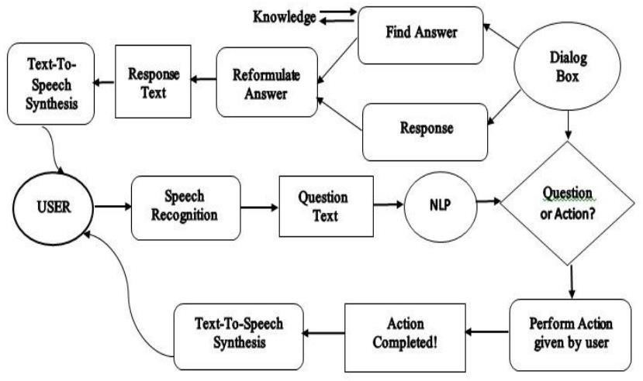

The main purpose of our intelligent virtual assistant is to answer questions that users may have.

Virtual assistants can tremendously save you time. We usually spend hours in online searches and then making the report in our terms of understanding. Our virtual assistant can do that for you. Provide a topic for research and continue with your tasks while it does the research.

Another difficult task is to open up applications by switching tabs which takes a lot of our precious time. Just tell the assistant what you want to open and see the magic. One of the main advantages of voice searches is their rapidity.

# To be a wise voice is reputed to be four times faster than a written search: whereas we can write about 40 words per minute, we are capable of speaking around 150 words during the same period.

In this respect, the ability of personal assistants to accurately recognize spoken words is a prerequisite for them to be adopted by consumers.

**III. PROPOSED SYSTEM**

Our virtual assistant focuses on removing the need for the user to type text input and instead relying on speech as the primary mode of user input. The agent then records the input after applying voice recognition techniques to it. It then uses this information to call one of the personal information management programs, such as a task list or calendar, to create a new entry or to conduct a search on Google, Bing, or Yahoo, among others. The emphasis is on gathering user input via voice, recognizing it, and then completing tasks if the agent understands them. Software interprets this data in normal language, making it easier for the user to specify what he or she wants done.

Voice recognition software enables hands free use of the applications, lets users to query or command the agent through voice interface. This helps users to have access to the agent while performing other tasks and thus enhances value of the system itself. Our Assistant will also have ubiquitous connectivity through Wi-Fi or LAN connection, enabling distributed applications that can leverage other APIs exposed on the web without a need to store them locally.

Virtual assistants must provide a wide variety of services. These include:

* + Providing information such as weather, facts from e.g., Wikipedia etc.
  + Set an alarm or make to-do lists and shopping lists.
  + Remind you of birthdays and meetings.
  + Play music from streaming services such as Saavan and Gaana.
  + Play videos, TV shows or movies on televisions, streaming from e.g., Netflix or

Hotstar.

* + Book tickets for shows, travel and movies.

**IV.METHODOLOGY**

An application of a natural language processing-based intelligent voice assistant system that may be used to transmit text messages. Messages may be sent and received, and the device's other applications can be used on the platform of was designed and implemented utilizing python android.

1. ***Tasks that are Supported***
   * + Call someone from my contacts list
     + Download any app.
     + Send a text message to someone
     + Schedule a meeting at 9 a.m. tomorrow on my calendar
     + Set your alarm for 5 a.m. tomorrow.
     + I'd want to play a certain song
     + Write an email.
     + Make a new note

# In most cases, a user must manually manage many sets of applications in order to execute a single operation. A user planning a trip, for example, should look up airport codes for neighboring airports and then search travel sites for tickets between airport combinations to get to their destination. A system that can effortlessly manage chores is required.

We already have a number of virtual assistants on staff. However, we hardly ever utilize it. A large number of people struggle with speech recognition. These systems are capable of understanding English phrases, but they are unable to distinguish our dialect. Our pronunciation differs significantly from theirs. They are also more user-friendly on mobile devices than desktop systems. A virtual assistant who can understand English with an Indian accent and work on a desktop system.

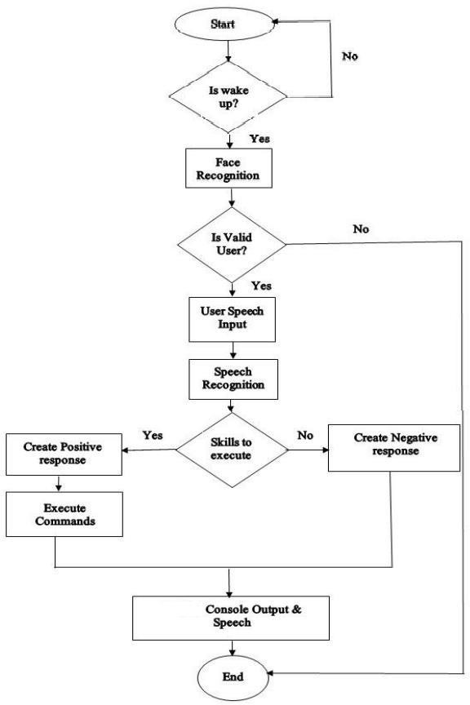

1. ***Data Flow***

1. ***System Modules***
   * **WolframAlpha** - It is used to compute expert-level answers of any command using Wolfram’s algorithms, knowledgebase and AI technology.
   * **JSON** - JavaScript Object Notation. JSON is a lightweight format for storing and transporting data. JSON is used when data is sent from a server to a web page. JSON is "self-describing" and easy to understand.
   * **Speech recognition** - Speech recognition means that when humans are speaking, a machine understands it. In our project we are using Google Speech API in Python to make software which is used to run machines on command.
   * **PyAudio** - We need to install the PyAudio python package for recognize the voice commands. PyAudio is installed using pip install PyAudio command.
   * **gTTS** - Google’s text-to-speech packages converts your audio questions command to text. The response from the look-up function that you write for fetching answer to the question or command is converted in an audio form by gTTS. This package interface with Google Translate’s API.
   * **Datetime** - Datetime package is used to showing Date and Time. This datetime module comes with built in Python.
   * **Wikipedia** - We all know Wikipedia is a great and huge source of knowledge just like GeeksforGeeks or any other sources we have used the Wikipedia module in our project to get more information from Wikipedia or to perform a Wikipedia search. To install this Wikipedia module, use pip install Wikipedia.
   * **WebBrowser** - To perform Web Search. This module comes built-in with Python.
   * **OS** - The OS module in Python provides functions for interacting with the os. OS comes under Python’s standard utility modules. This module provides a way of using operating system dependent functionality.

* **Pyjokes** - Pyjokes is used for collection Jokes over the Internet. Pyjokes is add in our project because it adds jokes in our project. It is very interesting Pyjokes is the one-line joke which makes our project interesting.
* **PyAudio**- PyAudio is a set of Python bindings for PortAudio, a cross- platform C++ library interfacing with audio drivers.
* **Smtplib**- The simple mail transfer protocol library is a Python library for sending emails using the Simple Mail Transfer Protocol (SMTP). The smtplib is a built-in module in python; do not need to install it. It abstracts all the complexities of SMTP away. It provides a Simple Mail Transfer Protocol (SMTP) client implementation.
* **Requests**- Requests module allows you to send http requests using python. It is used for making GET and POST requests. It abstracts the complexities of making requests behind a beautiful, simple API.

1. **CONCLUSION**

The desktop assistant's efficiency has been greatly increased in terms of functionality, and it also monitors the user's security using voice recognition technologies.

It's called advanced desktop assistant since it includes a lot of sophisticated capabilities that Microsoft Cortana doesn't have.

With significant features, this assistant is also focused on the user interface, which is necessary because Cortana lacks a user-friendly interface. A new desktop assistant is required to provide next-generation services, allowing us to make desktops as user-friendly as mobile devices.

The Contact’s Application is used to store the client's contact details and also encourages the customer to make a call or send an SMS to other people individual who is using the chemical stored in this app.

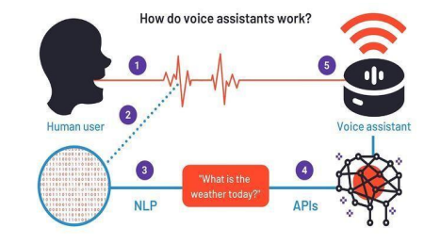

1. ***FUTURE SCOPE***

Virtual assistants are now available and are quick and responsive, but there is still a long way to go. The present systems' understanding and dependability must be improved. It has vastly improved.

Today's aides are still insufficient. In critical situations, it's dependable.

These helpers' future will be bright. Artificial Intelligence (AI) should be implemented into virtual assistants. Machine Learning and Neural Networks are examples of intelligence. IoT and networks, for example.

With the addition of these, we shall be able to reach new heights thanks to technological advancements. What really is the situation?

What virtual assistants can accomplish is far beyond what we now have, achieved up until now Jarvis is a virtual reality that most of us have seen.

**VI. ACKNOWLEDGMENT**

In this research, we created a voice assistant that can perform any task in exchange for requests from users without making any mistakes. More capabilities have been added, such as the ability to listen to the user's voice.

Exclusively, and will not be activated by noise in the environment. This project's modular design makes it simple to modify, understandable and adaptable. We can expand the program's capabilities without affecting its functionality.

All The necessary Python packages have been installed, and the code has been written in Python.

Integrated Development Environment (IDE). The python version used for this project is 3, and the python version used for this project is 3.

Data on various noises were maybe collected from the environment as part of the methodology.

1. **REFERENCES**

* **Webs 1. Website referred:**

[www.stackoverflow.com](http://www.stackoverflow.com)

www.pythonprogramming.net

[www.codecademy.com](http://www.codecademy.com)

[www.tutorialspoint.com](http://www.tutorialspoint.com)

* **Book 2. Books Referred:**
* Python Programming -Kiran Gurbani
* Learning Python – Mark Lutz
* Hands-on Machine Learning with Scikit-Learn (O’Reilly)
* **You 3. YouTube Channels Referred:**
* Code with Harry
* Edureka!
* Programming with Mosh
* **Docu 4. Documents Referred:**

1. C.K. Gomathy. (2010),"Cloud Computing: Business Management for Effective Service Oriented Architecture" International Journal of Power Control Signal and Computation (IJPCSC), Volume 1, Issue IV,
2. Mohit Bansal, Dr. T. K. Thivakaran, “Analysis of Speech Recognition using Convolutional Neural Network”, Journal of Engineering Sciences, Vol 11, Issue 1, 2020, Page 285-291.
3. C K Gomathy and V Geetha. Article: A Real Time Analysis of Service Based Using Mobile Phone Controlled Vehicle Using DTMF For Accident Prevention. International Journal of Computer Applications 138(2):11-13, March 2016. Published By Foundation of Computer Science (FCS), NY, USA, ISSN No: 0975-8887
4. Ossama Abdel-Hamid, Abdelrahman Mohamed, Hui Jiang, Li Deng, Gerald Penn, and Dong Yu, “Convolutional Neural Networks for Speech Recognition”, IEEE/ACM Transactions on Audio, Speech, and Language Processing, vol.22,2010.
5. Dr. Jaydeep Patil, Atharva Shewale, Ekta Bhushan, Alister Fernandes, Rucha Khartadkar, "A Voice Based Assistant Using Google Dialogflow and Machine Learning", International Journal of Scientific Research in Science and Technology (IJSRST), Online ISSN : 2395-602X, Print ISSN : 2395-6011,
6. Nil Goksel-Canbek2 Mehmet EminMutlu, “On the track of Artificial Intelligence: Learning with Intelligent Personal Assistant” International Journal of Human Sciences, 13(1), 592-601. doi:10.14687/ijhs.v13i1.3549.